**To do list：**

1. Implement DFT, DCT and Hadamard transform based on the unitary transform definition:

$$t=Af$$

For example, for DFT:

$A\left[k,n\right]$ = $e^{-j\frac{2πkn}{N}}$ = $cos(2π\frac{kn}{N})$- $jsin(2π\frac{kn}{N})$

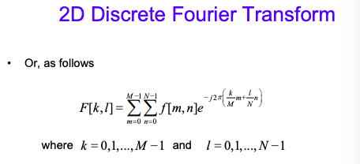

For DCT:

$$A\left[k,n\right]=\sqrt{\frac{2}{N}}cos\frac{π\left(2n+1\right)k}{2N}$$

